Really Dad? Rocky Mountain High
Posted on April 3, 2015 by Robert Lloyd
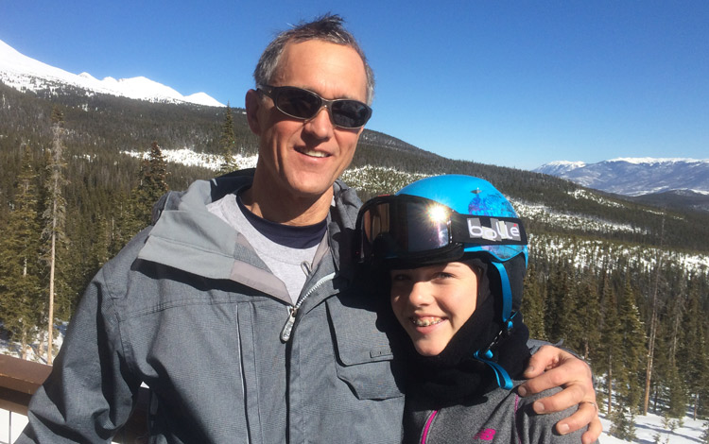

Michael
When my buddy, Tom, invited me to join him and two other guys on a father-daughter trip to Breckenridge, I was all in.
Twenty or more snowstorms ago, it seemed like a good idea, but by mid-March when we departed, and our yard still resembled the Artic tundra, an unbroken vista of white that had not yielded an inch since the beginning of the year, the prospect of flying most of the way across country to get to a colder and snowier place had lost some of its appeal.
We flew out of Windsor on a Thursday afternoon, four giddy girls and their fathers headed for a long weekend of skiing in Breckenridge where Tom’s brother and sister-in-law live. Their house was perched at the base of the resort, some 9800 feet above feet above sea level, causing us to huff and puff up the stairs with our bags. “Rapid,” Tom’s brother, was all accelerator and no brakes, fully amped at all times, and eternally optimistic, despite having endured a season-ending shoulder injury a week earlier.
His wife, Dee, or “Delicious” as the girls dubbed her, was the perfectly-reserved foil for her hyper husband, and a generous tour guide, taking us up all five peaks, knowing where the groomed trails would be in the early morning, which bowls to bomb once the sun had hit them long enough, and how to avoid lift lines. The girls made fast friends, energizing and emboldening each other to carve some steep bowls and blast some tight tree runs. When they disappeared into the woods, we could keep track of them from the slopes by listening to their squeals of laughter echoing in the forest. The girls ate sandwiches that we dads carried in our backpacks, not wanting to waste any time in the lodge, skiing run after run down the diamond and double diamond trails.
We rode up the highest lift in the United States — which is 12,898 feet. From there you can hike up another 100 vertical feet if you have the lungs to carry your gear up the makeshift snow stairs to the absolute top of the world. The other fathers and daughters climbed that last bit, (including one of the fathers who had recently blown out his knee skiing) but Mickey and I were content to ski down to the Vista Haus, mid-mountain, to take a sun-bath on the patio.
Every night the girls lounged in the in the hot tub for an hour, even snow rolling one evening to get the endorphins flowing. After dinner, they sang along to the music piped into speakers through their I Phones, gave each other mini-makeovers and even washed the dishes on one night. We dads kept waiting for them to crash, night after night, but it never happened. Even though the youngest was 11 and Mickey was the oldest at 14, there was no whining and lots of smiles.
Too quickly Thursday had melted into Monday, and we had to head back to Denver to catch a plane. But first we spent a sun-drenched morning shopping on Main Street in Breck, ducking in and out of chic stores selling tee shirts, jackets hats, and other touristy items that we made room for in our already over-stuffed bags.
The younger girls were all holding their fathers’ hands, so apparently it was cool for Mickey to hold mine. Sure Breckenridge boasts of some of the best skiing in the country, but there was no greater thrill for me than walking down Main Street, the spring sun warm on my face, holding Mickey’s hand.
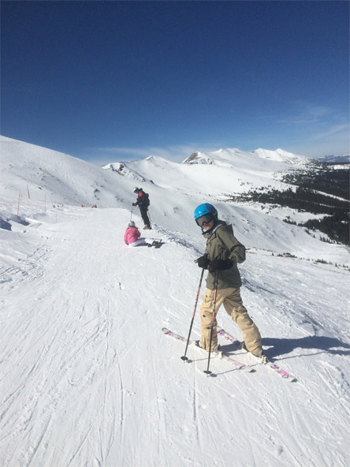
Michaela
Each time we rode a chairlift, we got to the top and were presented with the same view, yet it never ceased to take our breath away. It was 12,898 feet in the air. It felt like we were standing on top of the world. We looked down, and far below us stood the trees. The wind whispered through the branches, sending beautiful little clouds of crystals skating across the mountain. The crystals were taunting us to join them. To drop down into the bowl and ride this astonishing creation with them.
We pointed our boards downhill, let gravity take over, and began to fly. It was hard not to feel completely vulnerable in this instant, but if you thought too hard about how fast you were going, you might wipe out. I just turned off that part of my brain and soared down the mountain, completely unafraid. . We carved down the mountain as fast as we could, ducking into the trees whenever there was a trail, and sometimes, when there wasn’t. I have never skied faster or further. I loved every second of every run.
At Breckenridge, there are five main peaks. On each peak, there is a base lodge and warming hut or restaurant lodge at the top. One of the peaks, Peak 7, has a lodge at the bottom aptly named the Grand Lodge, where my dad and I met some friends after the last run of our final day there. As I neared the bottom, I could see a five story building with balconies overlooking a large patio, with a view toward the mountains. When I popped out of my skis and leaned them against the fence, I noticed that there were three hot tubs, an outdoor heated pool that flowed indoors if you swam through the freezer flaps hanging down, and grills sizzling with hamburgers and hotdogs. Just on the other side of the fence people were wearing bikinis and shorts as they splashed in the water and walked on the heated patio.
Our friends had told us to bring our bathing suits, but as I opened the gate and clomped onto the patio with my ski boots, I kept thinking how surreal this was: on one side of the gate it was winter, and just a few inches on the other side, it was summer. I felt out of place in my boots and ski parka, but once we changed into our suits I made the transition in my head. We spent a few hours jumping in and out of the water, and getting too much sun, in spite of the sunscreen we slopped on. When it was time to go, it was back to winter again. We had to go back into the changing room, put on our winter gear, including our ski boots, to catch the shuttle back to the house.
When we were walking back to the bus stop, I caught a whiff of something that smelled like a skunk. I mentioned it to my dad, who explained that the smell was marijuana which is legal in Colorado. I added that to the list of unforgettable experiences in Breckenridge. The three days I stayed in Breckenridge Colorado will live with me forever. It was the most incredible experience I have ever had. I’m not sure that skiing in Vermont will ever be the same again.

